Lab 6: Repetition Structures
This lab accompanies Chapter 5 of Starting Out with Programming Logic & Design.

Name: ___________________________

Lab 6.1 – For Loop and Pseudocode

Critical Review

A count-controlled loop iterates a specific number of times. Although you can write this with a while or a do-while loop as performed in Lab 5, most programming languages provide a loop known as the for loop. This loop is specifically designed as a count-controlled loop.

The process of the for loop is:
- The loop keeps a count of the number of times that it iterates, and when the count reaches a specified amount, the loop stops.
- A count-controlled loop uses a variable known as a counter variable to store the number of iterations that it has performed.
- Using the counter, the following three actions take place (Initialization, Test, and Increment).

The pseudocode for a for statement looks as follows:

For counterVariable = startingValue to maxValue
Statement
Statement
Statement
Etc.
End For

This lab requires you to implement a count-controlled loop using a for statement.

Step 1: Examine the following code.

Constant Integer MAX_VALUE = 5
Declare Integer counter

For counter = 1 to MAX_VALUE
Display “Hello World “, counter, “ times”
End For

Step 2: Explain what you think will be displayed to the screen in Step 1. (Reference: For loop, page 191):
Hello World 1 times
Hello world 2 times
Hello world 3 times
Hello world 4 times
Hello world 5 times

Step 3: Write a for loop that will print 30 days to the screen. Complete the missing lines of code.

Constant Integer MAX_DAYS = 30
Declare Integer days

For days = 1 to MAX_DAYS

Display “The day is “, days
End For

Step 4: Write a for loop that will print 10 squares of a number to the screen. Complete the missing lines of code to include “The Square of the Number” is: For more information see page 194.

Constant Integer MAX_SQUARES = 10
Declare Integer counter
Declare Integer square

For counter = 1 to MAX_SQUARES

Square = counter * counter

Display square
End For

Step 5: For loops can also be used to increment by more than one. Examine the following code.

Constant Integer MAX_VALUE = 50
Declare Integer counter

For counter = 10 to MAX_VALUE Step 5
Display “Counted value is “, counter
End For

Step 6: Explain what you think will be displayed to the screen in Step 5. (Reference: Incrementing by Values Other than 1, page 196):
Counted value is 10
Counted value is 15
Counted value is 20
Counted value is 25
Counted value is 30
Counted value is 35
Counted value is 40
Counted value is 45
Counted value is 45

Step 7: Write a for loop that will display the numbers starting at 100, then 200, then 300, and continuing the sequence all the way to 900.

Constant Integer MAX_VALUE = 900
Declare Integer index

For index = 100 to MAX_VALUE Step 100
Display “The number is “, index
End For

Step 8: For loops can also be used when the user controls the number of iterations. Examine the following code:

Declare Integer numHours
Declare Integer index

Display “Enter the number of hours in class each day”
Input index

For numHours = 1 to index
Display “Class hour #”, numHours
End For

Step 9: Explain what you think will be displayed to the screen in Step 8. (Reference: Letting the User Control the Number of Iterations, page 200):
Class hour #whatever the user entered

Step 10, Multiplier: - For loops are also commonly used to calculate a running total. Examine the following code.

Declare Integer counter
Declare Integer product = 1
Declare Integer number

For counter = 1 to 4
Display “Enter a number between 1 and 10: “
Input number
Set product = product * number
End For

Display “The total is: “, product

Step 11: Explain what you think will be displayed to the screen in Step 10. (Reference: Calculating a Running Total, page 201):
The total is: Whatever the user entered multiplied by numbers 1 through 4

Step 12: Write the missing lines for a program that will allow the user to enter how many baseball scores they want to enter and then find the average. Note, please answer the problem as it is written for credit.

Declare Integer totalScores = 0
Declare Real averageScore = 0
Declare Integer score
Declare Integer number

Display “How many scores do you want to enter: “
Input number

For index = 1 to number
Display “Enter score: “
Input score
Set totalScores = totalScores + score
End For

averageScore = totalScores / number

Display “The average score is “, averageScore

Lab 6.2 –For Loop and Flowcharts

Critical Review

A flowchart for a for loop is similar to that of a while loop, where a condition controls the iterations. Here is an example of a for loop using a flowcharting tool such as Visio.
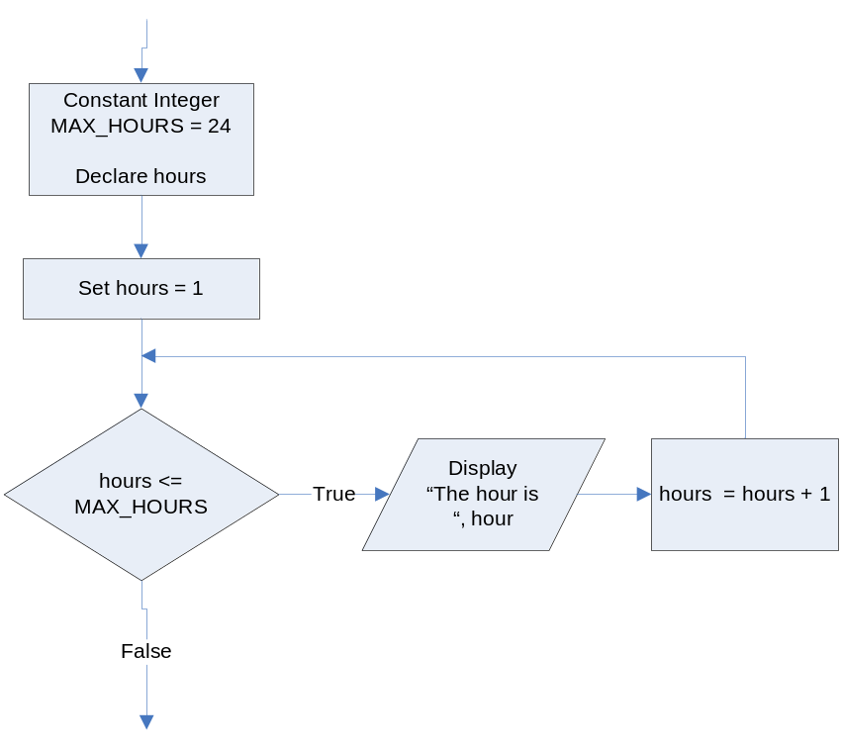

In Raptor, the for loop structure is a bit different because the programmer has less control over the loop symbol. Notice these difference in the following flowchart:

- The variables in are still declared and initialized to the same starting values.
- The condition is now hours > MAX_HOURS rather than hours <= MAX_HOURS. This is done because in Raptor, False or No statements continue the code and True or Yes statements end the code. This is the opposite as demonstrated in the textbook.
- The code within the loop is the same.

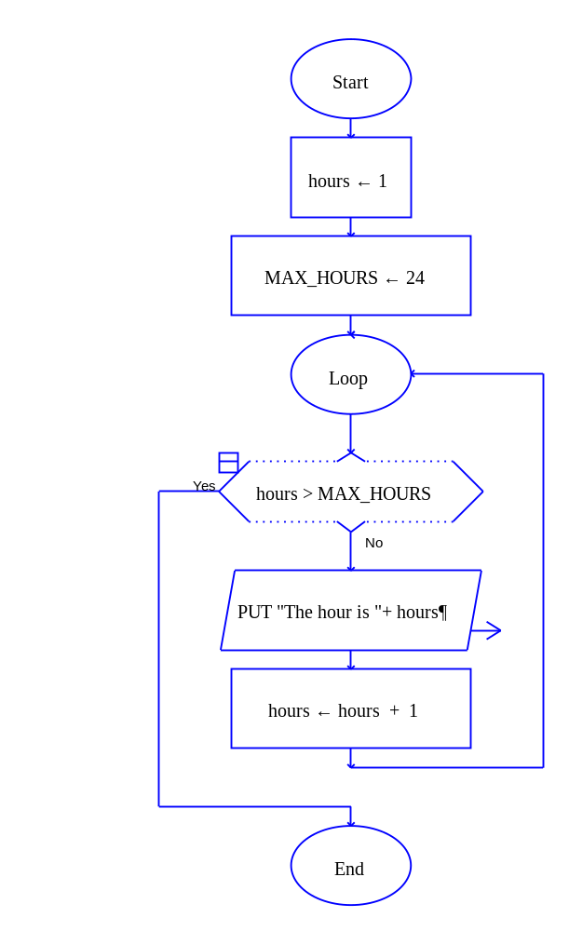

Help Video: View Video: Lab 6.2a

This lab requires you to convert various pseudocode steps in Lab 6.1 to a flowchart. Use an application such as Raptor or Visio.

The Days Counter
Step 1: Start Raptor and save your document as Lab 6-2Days. The .rap file extension will be added automatically.

Step 2: The first loop to code is the pseudocode from Step 3, Lab 6.1. This loop will print 30 days to the screen. The complete pseudocode is below:

Constant Integer MAX_DAYS = 30
Declare Integer days

For days = 1 to 30
Display “The day is “, days
End For

Step 3: Click the Loop symbol and add it between the Start and the End symbol. Above the Loop symbol, add two assignment statements. Set a variable named days to 1 and a variable named MAX_DAYS to 30.

Step 4: Double click the Diamond symbol and add the condition that will execute the loop through 30 iterations.
Innovate

Step 5: Add an output statement if the loop is NO. This statement will display the days variable to the screen.

Step 6: Add an assignment statement next that will increment the days variable by 1.

Step 7: Execute your flowchart to see if your output matches the following. If not, repeat the steps to identify the error and execute again.

The day is 1
The day is 2
The day is 3
…..Continues from 4 to 27……
The day is 28
The day is 29
The day is 30
----Run finished----

Step 8: Paste your finished flowchart in the space below.

PASTE FLOWCHART HERE

The Multiplier
Step 1: Start Raptor and save your document as Lab 6-2Multiplier. The .rap file extension will be added automatically.

Step 2: The next loop to code is the pseudocode from Step 10, Lab 6.1. This loop will take in a number and add it to the total. The complete pseudocode is below:

Declare Integer counter
Declare Integer total = 0
Declare Integer number

For counter = 1 to 4
Display “Enter a number between 1 and 10: “
Input number
Set total = total * number
End For

Display “The total is : “, total

Step 3: Click the Loop symbol and add it between the Start and the End symbol. Above the Loop symbol, add three assignment statements. Set a variable named counter to 1, a variable named total to 1, and a variable named number to 0.

Step 4: Double click the Diamond symbol and add the condition that will execute the loop through 4 iterations.

Step 5: Add an input statement if the loop is NO. This statement will ask the user to enter a number.

Step 6: Add an assignment statement that will multiply the total such as total = total * number.
Innovate
Step 7: Add an assignment statement that will increment the counter variable by 1.

Step 8: Add an output statement outside of the loop if the condition is YES. This should display total.

Step 9: Execute your flowchart to see if your output matches the following. If not, repeat the steps to identify the error and execute again.

Example Input values are:
4
7
3
2

The expected output is:
The total is 168
----Run finished----

Step 10: Paste your finished flowchart in the space below.

PASTE FLOWCHART HERE

The Average Score
Step 1: Start Raptor and save your document as Lab 6-2AverageScore. The .rap file extension will be added automatically.

Step 2: The next loop to code is the pseudocode from Step 12, Lab 6.1. This loop will take in various amounts of baseball scores and then find the average. The complete pseudocode is below:

Declare Integer counter
Declare Integer totalScores = 0
Declare Real averageScore = 0
Declare Integer score
Declare Integer number

Display “How many scores do you want to enter: “
Input number

For counter = 1 to number
Display “Enter score: “
Input score
Set totalScores = totalScores + score
End For

averageScore = totalScores / number

Display “The average score is “, averageScore
Innovate
Step 3: Click the Loop symbol and add it between the Start and the End symbol. Above the Loop symbol, add five assignment statements. Set counter to 1, totalScore to 0, averageScore to 0, score to 0, and number to 0.

Step 4: Above the Loop symbol, add an Input symbol that asks the user how many scores they want to enter. Store the answer in the number variable.

Step 5: Double click the Diamond symbol and add the condition that will execute the loop as long as the number is less than the counter. This can be written as counter > number.

Step 6: Add an input statement if the loop is NO. This statement will ask the user to enter a score.

Step 7: Add an assignment statement that will multiply to find the totalScores.

Step 8: Add an assignment statement that will increment the counter variable by 1.

Step 9: Add an assignment statement outside of the loop if the condition is YES. This should calculate the averageScore as averageScore = totalScores / number.

Step 10: Add an output statement outside of the loop if the condition is YES. This should display averageScore.

Step 11: Execute your flowchart to see if your output matches the following. If not, repeat the steps to identify the error and execute again.

Input values are:
4 – how many scores to enter

12
5
13
6
3

The expected output is:
The average score is 7.8
----Run finished----

Step 12: Paste your finished flowchart in the space below.

PASTE FLOWCHART HERE

Lab 6.3 – Python Code
Critical Review

You use the for statement to write a count-controlled loop. In Python, the for statement is designed to work with a sequence of data items. When the statement executes, it iterates once for each item in the sequence. The general format is as follows:

for variable in [value1, value2, etc.]:
statement
statement
etc.

Using the range function

When it is too cumbersome to print all the values to be displayed, Python has a range function that can be used. If you pass one argument to the range function, that argument is used as the ending limit of the list. If you pass two arguments to the range function, the first argument is used as the starting value of the list and the second argument is used as the ending limit. Here are two examples:

for num in range(5):  print num  This code will display the following:  0  1  2  3  4 | for num in range(1, 5):  print num  This code will display the following:  1  2  3  4

Letting the User Control the Number of Iterations

Sometimes the programmer needs to let the user control the number of times that a loop iterates. This is done by first letting the user enter how many times they want their loop to execute. Then, the range function is used to control the iterations. It is important to use the starting value of 0 for the loop to execute the exact number of times. The general format is as follows:

number = input('How many iterations do you want: ')

for counter in range(0, number):
Statements…
Statements…

Help Video: View Video: Lab 6.3

The goal of this lab is to convert all flowcharts in Lab 6.2 to Python code.

Step 1: Start the IDLE Environment for Python. Prior to entering code, save your file by clicking on File and then Save. Select your location and save this file as Lab6-3.py. Be sure to include the .py extension.

Step 2: Document the first few lines of your program to include your name, the date, and a brief description of what the program does.

Step 3: Start your program with the following code for main:

#Lab 6-3 Practicing for loops

#the main function
def main():

#A Basic For loop

#The Max Days Counter code

#The multiplier code

#The Average Score code

#calls main
main()

Step 4: Under the documentation for A Basic For Loop, add the following lines of code:

print 'I will display the numbers 1 through 5.'
for num in [1, 2, 3, 4, 5]:
print num

On the first iteration, 1 is placed into the variable num and num is then printed to the screen. The process is continued as follows:

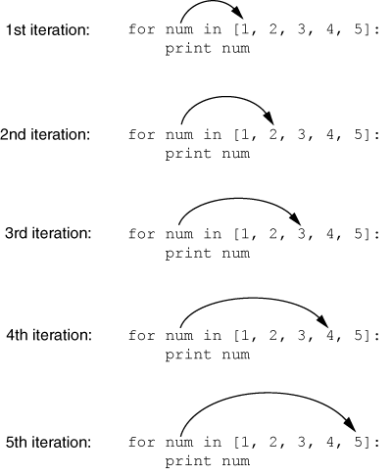
Innovate

Execute your program. Notice that the output is as follows:

>>>
I will display the numbers 1 through 5.
1
2
3
4
5
>>>

Step 5: The next loop to code is the Second Counter code. This loop can be processed in the same way as Step 4; however, it would take a long time to write 1 through 30 in the for loop definition. Therefore, the range function should be used to simplify the process. Write a for loop that has a range from 1 to 31. If you stop at 30, only 29 days will be printed. If you only provide one argument, the starting value will be 0. (Reference the Critical Review section above for the exact syntax.)
Innovate

Step 6: The next loop to code is the Multiplier code. Start by initializing a total variable to 0. This must be done in order to accumulate values.

Step 7: The next step is to write a for loop that iterates 4 times. The easiest way to do this is the following.

for counter in range(4):

Step 8: Inside the for loop, allow the user to enter a number between 1 and 10. Then, add a multiplication statement that multiplies the number against the total. In Python, the range function determines the number of iterations, so it is not necessary to manually increment counter.
Innovate

Step 9: Outside of the for loop, use a print statement that will display the total.

Step 10: Compare your sample input and output to the following:

Enter a number: 3
Enter a number: 9
Enter a number: 2
Enter a number: 6
The total is 324

Step 11: The final loop to code is the Average Score code. Start by initializing totalScores and averageScore to 0. (Reference the Critical Review section above on Letting the User Control the Number of Iterations).

Step 12: The next step is to ask how many scores they want to enter. Store the answer in the number variable.

Step 13: Write the definition for the for loop using the range function such as:

for counter in range(0, number):

Step 14: Inside the for loop, allow the user to enter a score.

Step 15: Inside the for loop, add the code that will accumulate score into the totalScores variable.

Step 16: Outside of the loop, calculate the averageScore as averageScore = totalScores / number.

Step 17: Outside of the loop, display the averageScore variable to the screen.

Step 18: Compare your sample input and output to the following:

How many scores do you want to enter: 6
Enter a score: 13
Enter a score: 4
Enter a score: 5
Enter a score: 1
Enter a score: 7
Enter a score: 10
The average score is 6.67
>>>
Innovate
Use the ‘round’ function to keep the decimal fraction to 2 digits.

Step 19: Execute your program so that all loops work and paste the final code below

PASTE CODE HERE

Lab 6.4 – Programming Challenge 1 – Pay Calculator

Write the Flowchart and Python code for the following programming problem based on the provided pseudocode.

Help Video for Raptor: View Video: Lab 6.4 Raptor
Innovate
Help Video for Python: View Video: Lab 6.4 Python

Write a program that will allow someone to calculate their monthly pay based on a 40 hour work week. The user enters the number of hours they worked in each week for a month (4 weeks) and their regular pay wage. Your program will then calculate the total monthly pay and print out the results. Your program must use the appropriate loops, modules, and run multiple times for different months of pay. Also, your program must account for more than 40 hours in the work week and pay time and a half for all hours over 40 in a week.

Your sample output might look as follows:

Enter the number of weeks you want to calculate pay for : 4
Enter the pay wage: $ 10
Enter week 1 hours: 32
Enter week 2 hours: 45
Enter week 3 hours: 40
Enter week 4 hours: 26
The total pay is $:1455
Do you want to end program? (Enter no to process a new set of pay): yes
The Pseudocode

Module main()
//Declare local variables
Call declareVariables (endProgram, totalPay, hours, wage, weeks, counter)
//Loop to run program again
While endProgram == “no”
//reset variables
Call declareVariables (endProgram, totalPay, hours, wage, weeks, counter)

//calls functions
Call getWeeks(weeks, counter)
Call getWage(wage)
Call getPay(totalPay, weeks, wage, hours, counter)
Call printTotalPay(totalPay)
Display “Do you want to end the program? (Enter no to process a new set of pay )”
Innovate
Input endProgram
End While
End Module

Module declareVariables(Real Ref endProgram, Real Ref totalPay, Real Ref hours, Real Ref wage, Integer Ref weeks, Integer Ref counter)
Declare String endProgram = “no”
Declare Real totalPay = 0.0
Declare Integer hours = 0
Declare Real wage = 0
Declare integer weeks = 0
Declare Integer counter = 1
End Module

Module getWeeks(Integer Ref weeks, Integer counter)
Display “How many weeks would you like to calculate pay for?: ”
Input weeks
End Module

Module getWage(Integer Ref wage)
Display “How much is your weekly wage: ”
Input wage
End Module

Module getPay(Real Ref totalPay, Integer weeks, Real wage, Real hours, Integer counter)
For counter = 1 to weeks
Display “Enter the hours “, counter, “ hours:”
Input hours
Set totalPay = totalPay + (hours * wage)
if hours > 40 then
Set totalPay = totalPay + ((hours – 40) * (wage / 2))
end if
End For
End Module

Module printTotalPay(Real totalPay)
Display “The total pay is “,totalPay
End Module

The Flowchart

PASTE FLOWCHART HERE

The Python Code

PASTE CODE HERE

